Systems Analysis

and Design

Instructor : Huang, Chuen-Min

**Teamwork ver.1**

Group 7

|  |  |
| --- | --- |
| ID | Name |
| B10423042 | Jonathan |
| B10423046 | Vicky |
| B10123034 | Celia |
| B10523003 | Hank |
| B10523005 | Aliss |
| B10523021 | Johnny |
| B10523027 | Blaire |
| B10523046 | Reo |
| B10523054 | Michael |
|  |  |
| Date 2018/ 5 / 8 | |

Contents

1. Describe the Project in Text. 2

2. Use Case Diagram 3

3. Use Case Description 5

4. Activity Diagram 6

[Recognize Car] ( The Most Important ) 6

[Calculate Parking Space] 8

[Register Parking Car] 10

[Enter the Parking Lot] 12

[Pay Payment] 14

[Leave the Parking Lot] 16

5. Sequence Diagram 18

6. Class Diagram 20

7. Behavior State Machine 22

8. Participate In Assignments 24

# Describe the Project in Text.

**Bang Parking System** is used in parking lot. Nowadays, there’re still many parking lot using magnetic card ticket. Although it is convenience enough, our system provide a faster way for parking.

By recognizing car plate and connecting with parking space, it doesn’t need customer to reach out for the ticket that may waste the time. Furthermore, using our system can avoid the problem that customer may drop their card tickets accidentally. When you’re ready for leaving, it comes to the payment procedure. Our system will calculate how much customer should pay by using the parking information which contains the car plate, number of parking space, and parking time. Not only that, it also let customer use Easy Card or just cash to pay for it. Certainly, it makes park much easy and rapid.

# Use Case Diagram

The Bang Parking System consists of four main functions: “calculate parking space”, “recognize car”, “register parking car” and “pay payment”.

At the beginning, customers arrive the entrance of parking lot, system will return Calculate Parking Space State, like remaining number of parking spaces, and Recognize Car, like car plate. Then enter the parking lot and park completely, system will Register Parking Car, such as connect parking space to the plate, and create car information. These recorded data will be saved in parking data base. Final, customers Pay Payment to leave the parking lot. And the system will delete the record.

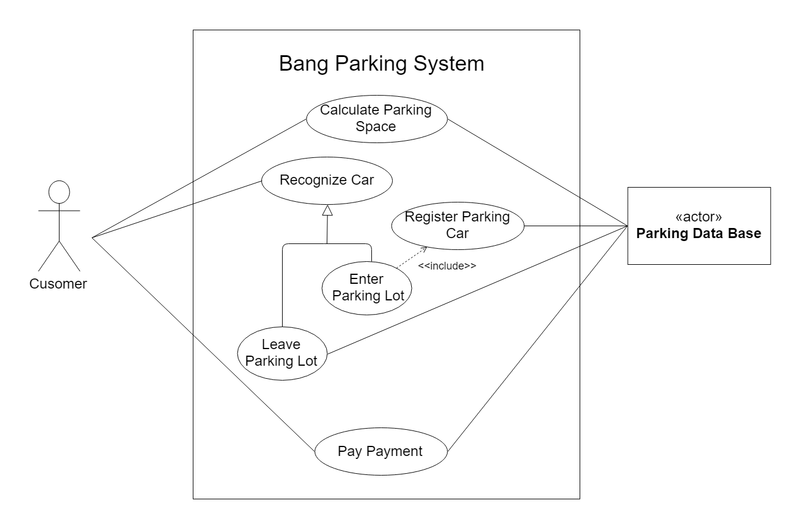

# **Use Case Description**

|  |  |  |
| --- | --- | --- |
| **Use Case Name**: Recognize Car | **ID**: 1 | **Importance Level**: High |
| **Primary Actor**: Customer | **Use Case Type**: Overview, Essential | |
| **Stakeholder and Interest**:  Customer - wants to park the car. | | |
| **Brief Description**: This use case can recognize license plate. | | |
| **Trigger**: Customer stops car in front of camera.  **Type**: Internal | | |
| **Relationship**: | | |
| Association: Customer  Include: Register Parking Car  Extend:  Generalization: |  | |
| **Normal Flow of Event**:  N1. The car stops at gate of park space.  N2. The camera takes a picture about car.  N3. The Recognize system catches the license plate photo in picture.  N4. The Recognize changes license photo into license data.  N5. The Recognize output license plate, time, camera number to Register. | | |
| **Sub Flows**:  S3.1 The picture, about license plate is unclear. Back to N2.  S4.1 The system can’t change license plate into data. Back to N2. | | |
| **Alternative/Exceptional Flows**:  N2-a1. The license plate is too dirty to analysis.  N2-a2. The car hasn’t license plate.  N2-a3. The fake license plate is same with another license plate in parking lot. | | |

# **Activity Diagram**

## [Recognize Car] ( The Most Important )

The activity diagram describes the steps in a use case of recognize car. After customer parked car, the camera will take picture of whole car. And then the system will denoise the picture. Once the picture is low noise, the system will strengthen the contrast and capture the car plate.

If capture failed, the system will take picture once again. If capture successfully, will split picture into single characters. Finally, will compare each single character to string data. If failed, will return to take picture again. If successful, will output.

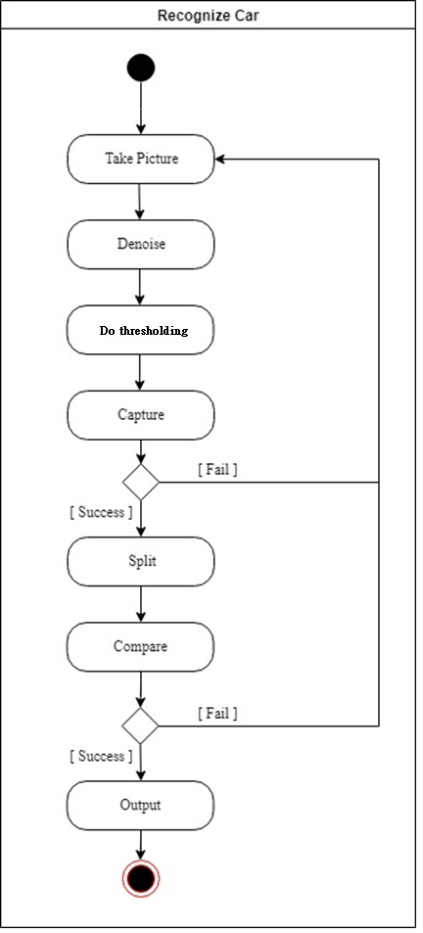

## [Calculate Parking Space]

The activity diagram describes the steps in a use case of calculate parking space. First, system gets parking space data from database, after that system began to calculate the remaining amount of parking spaces. If the parking spaces is full, output data “Full”, whereas, output data “Not full”, then saves that into database.

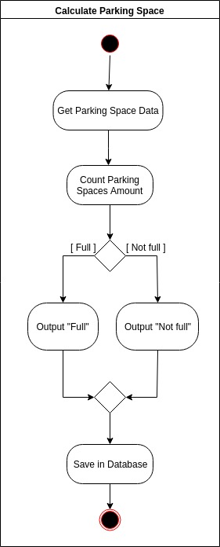

## [Register Parking Car]

The activity diagram describes the steps in a use case of register parking car. After customer enters the parking lot and recognize system identifies information from pictures, then get information of parking spaces, car plate and admittance, at last create these information into parking information.

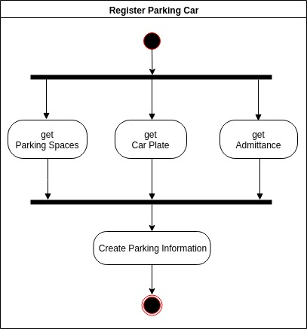

## [Enter the Parking Lot]

The activity diagram describes the steps in a use case of enter the parking lot that extends from recognize car. This diagram visually presents a series of actions or flow of control in the system.

The initial trigger is customer arrived the gate of the parking lot. After the recognize system identifies customer’s car plate, the gate will be opened. When customer parks their car, the system identify car plate again in order to compare the car plate with the database. If compare fails, the camera will take another picture until compare succeed. If compare succeeds, the system will connect this parking space number with car plate. In the end, the system will record parking time and save data to the database.

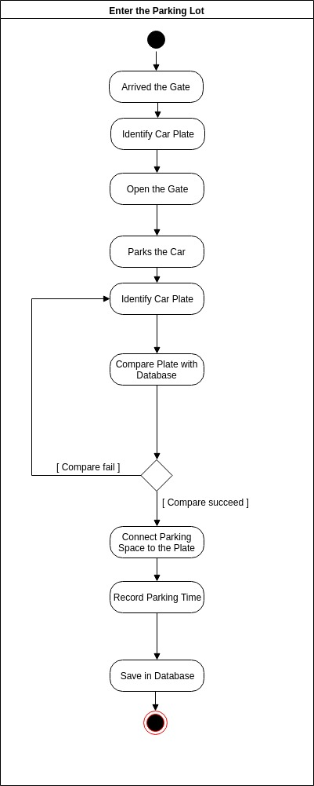

## [Pay Payment]

The activity diagram describes the steps in a use case of pay payment. This diagram visually presents a series of actions or flow of control in the system.

The initial trigger is customer input their car number to automatic pay station. The system will get parking information from database. And then the system will calculate how long the customer parked. After that, the system can also calculate how much customer should pay.

Customer can choose to pay by cash or by Easy Card. When customer select to pay by Easy Card, the system will examine whether the card’s balance is sufficient or not. If the balance is insufficient, the system will display fail and ask customer to choose the other way to pay. Once customer finish paying the bill, they can also choose to print the receipt or not.

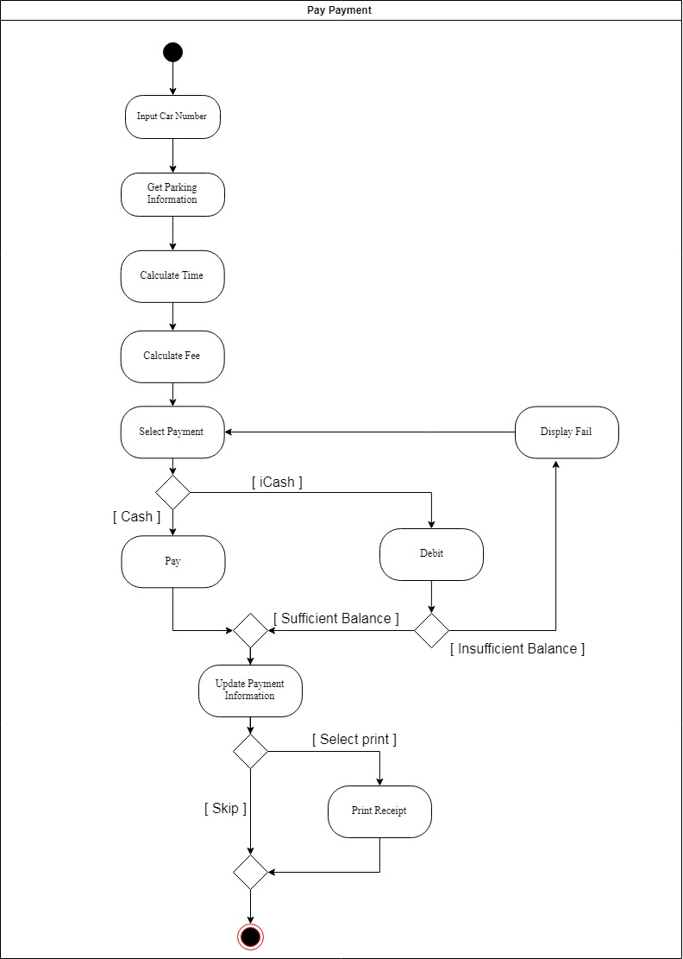

## [Leave the Parking Lot]

The activity diagram describes the steps in a use case of leave the parking lot that extends from recognize car. This diagram visually presents a series of actions or flow of control in the system.

The initial trigger is customer arrived the exit of the parking lot. After the recognize system identifies customer’s car plate, the system will get the payment information of this customer and ask the customer to pay the bill. If the payment is completed, the gate will be opened. If the payment fails, the system will reject the customer and prevented him/her from leaving until the customer complete payment. In the end, the system will delete this record.

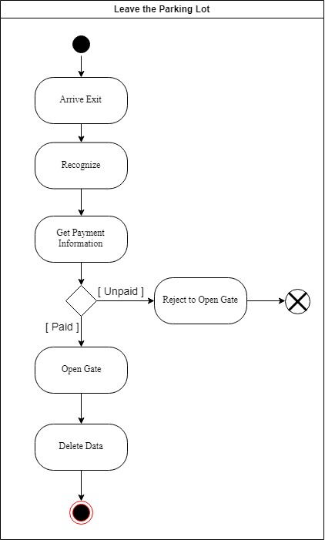

# Sequence Diagram

The sequence diagram shows the interactor sequence of recognize car and the objects. First, Recognize System takes picture then creates car picture, and the Picture shows the license plate recognition result back to the system. Then Recognize System will denoise, thresholding, and capture the picture, if capture is succeed, then it will cut word, character segmented, convert string, and if convert is succeed, the system will create license plate. If capture or convert is fail, the system will repeat to take picture until it is succeed.

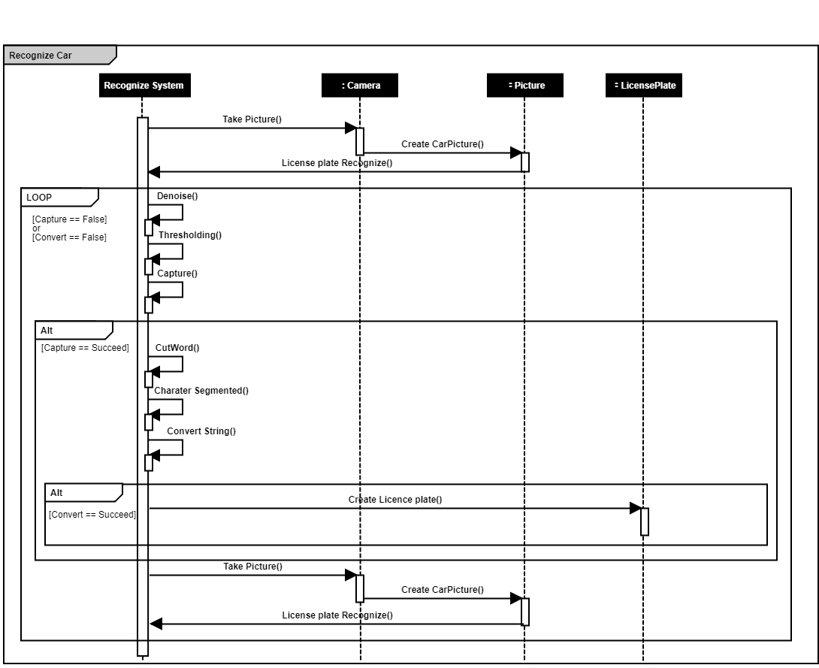

# Class Diagram

The Customer drive the Car into parking lot and park the Car that will trigger Recognize system to analysis License plate .When use the Recognize system ,who need to call Camera to take a Picture about car .

The Camera has cameraNum and time, each parking spaces has one Camera .The cameraNum can help Recognize system to know which parking space that Car is parked .The Picture include whole Car (need to recognize license plate), the Recognize system will denoise, thresholding and capture picture that only has License plate.

When successfully capture ,the Recognize system will go a step further to character segmentation and character matching .If all done , Recognize system will input the data to License plate ,that have license plate number, parking time ,and space number.

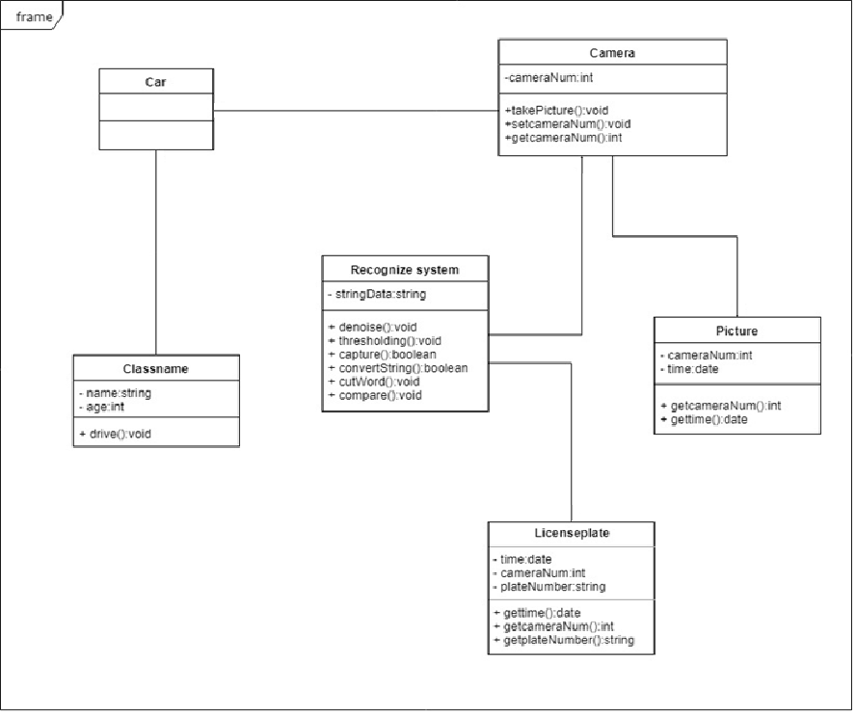

# Behavior State Machine

The behavior state machine is showing how picture change state. When the system gets the picture, the picture is in raw state.

After color processing by the system, the picture change into the color processed state.

After denoising, the photo status becomes low noise state.

To capture the car plate, the system will cross the low noise photos with the original photos.

If thresholding failede will end the system. If it succeeds, it will be binarized.

The vertical projection and horizontal projection of the photo will split picutre into many single characters and then compared with the string data and adjust the size. If it fails, the system will end. If size matched, then will output characters.

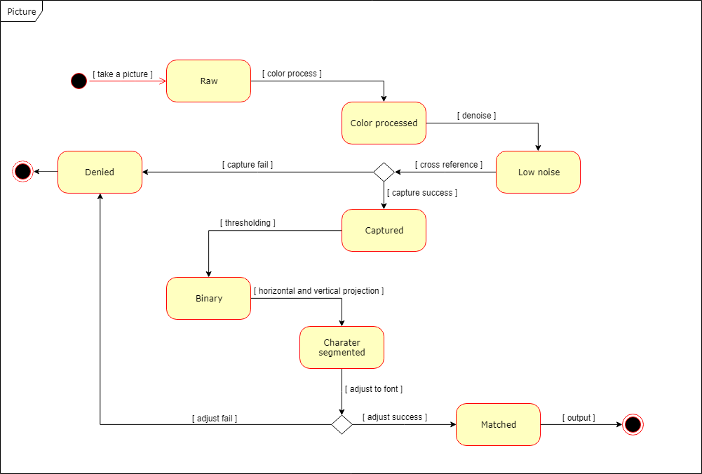

# Participate In Assignments

|  |  |  |  |
| --- | --- | --- | --- |
| ID | Name | Participate | Responsibility |
| B10423042 | Jonathan | 100% | use case diagram  use case description  activity diagram  detailed sequence diagram  class diagram  behavior state machine  check file |
| B10523027 | Blaire | 100% | use case diagram  use case description  activity diagram  Word & PPT  check file |
| B10523046 | Reo | 100% | use case diagram  use case description  activity diagram  detailed sequence diagram  class diagram  behavior state machine |
| B10523021 | Johnny | 100% | use case diagram  use case description  activity diagram  detailed sequence diagram  class diagram  behavior state machine  check file |
| B10523005 | Aliss | 100% | use case diagram  use case description  activity diagram  detailed sequence diagram  class diagram  behavior state machine |
| B10423046 | Vicky | 100% | use case diagram  use case description  activity diagram  Word & PPT |
| B10523054 | Michael | 100% | use case diagram  use case description  activity diagram  class diagram  behavior state machine  check file |
| B10123034 | Celia | 95% | check file  use case description |
| B10523003 | Hank | 100% | use case diagram  use case description  activity diagram  detailed sequence diagram  class diagram  behavior state machine |